Exp no:8 -Determination and plotting of Capacitance of Co-axial cable per unit length with different (i) inner radius, (ii) outer radius and (iii) relative permittivity of the dielectric medium.
Aim: To write program for Capacitance of co-axial cable per unit length using SCILAB. Software required:
- SCILAB version 6.0.1 Program:
- 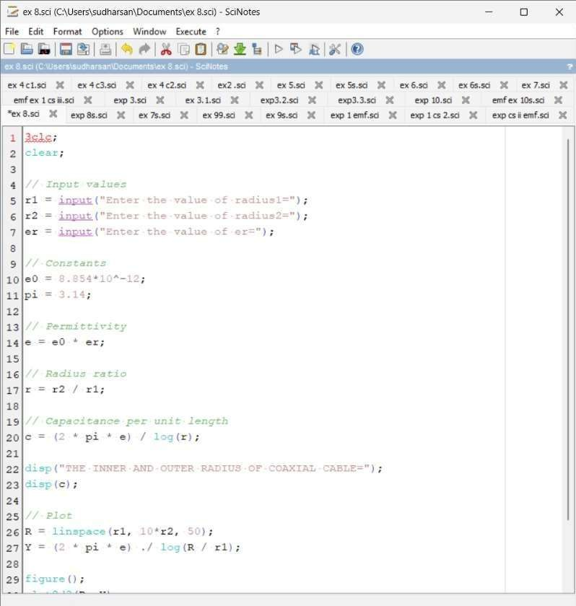

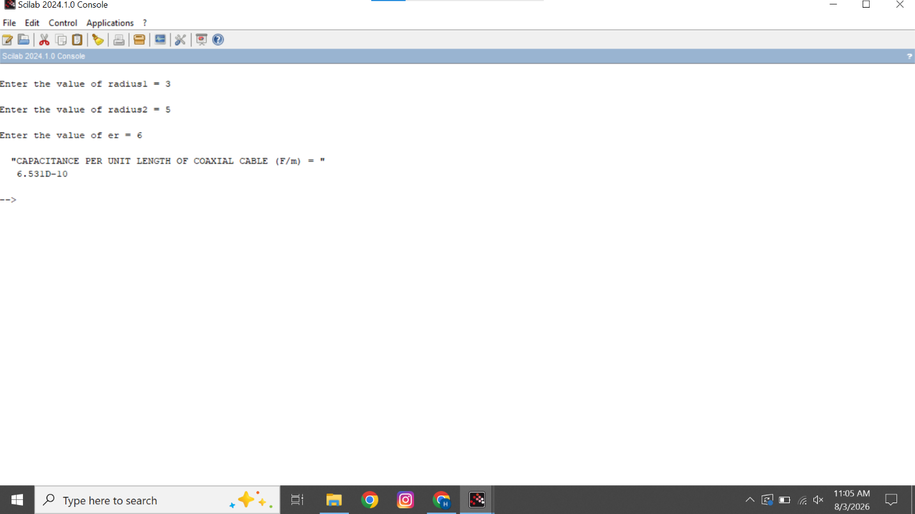
Output:

Calculation:

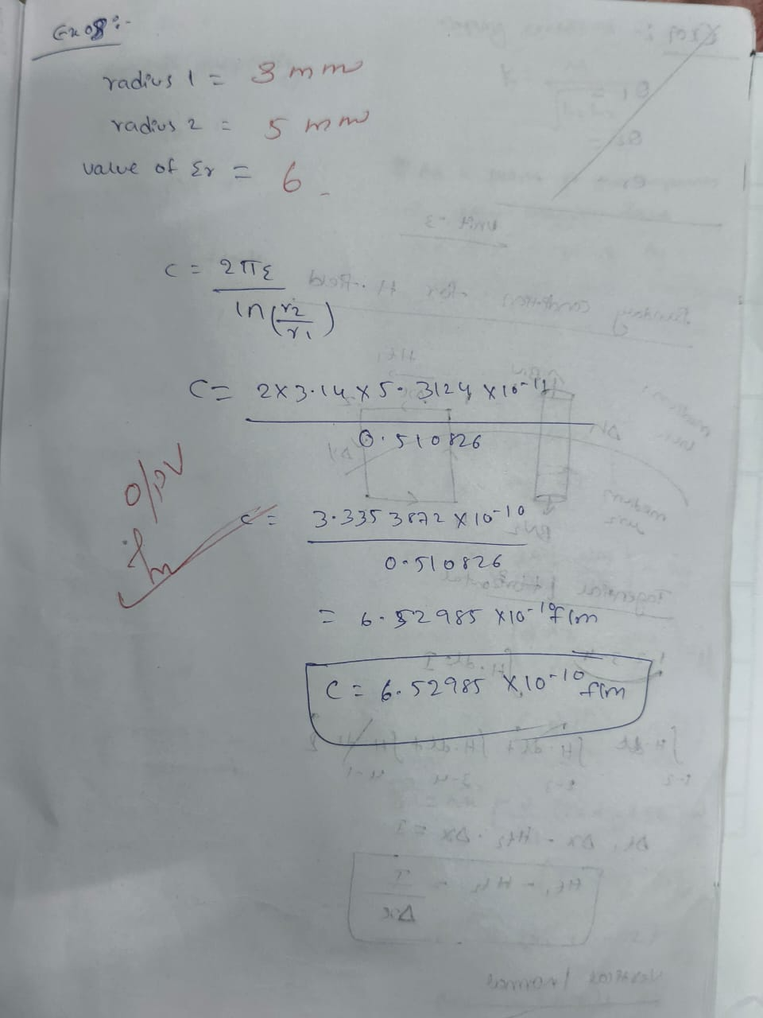

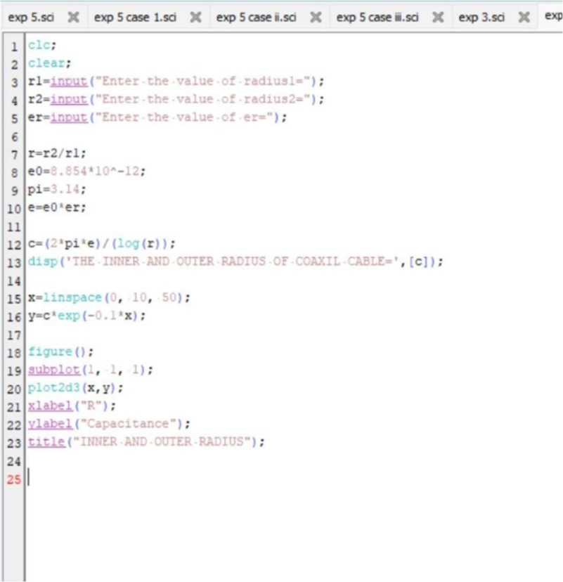
CASE STUDY 1: Variation with Inner Radius

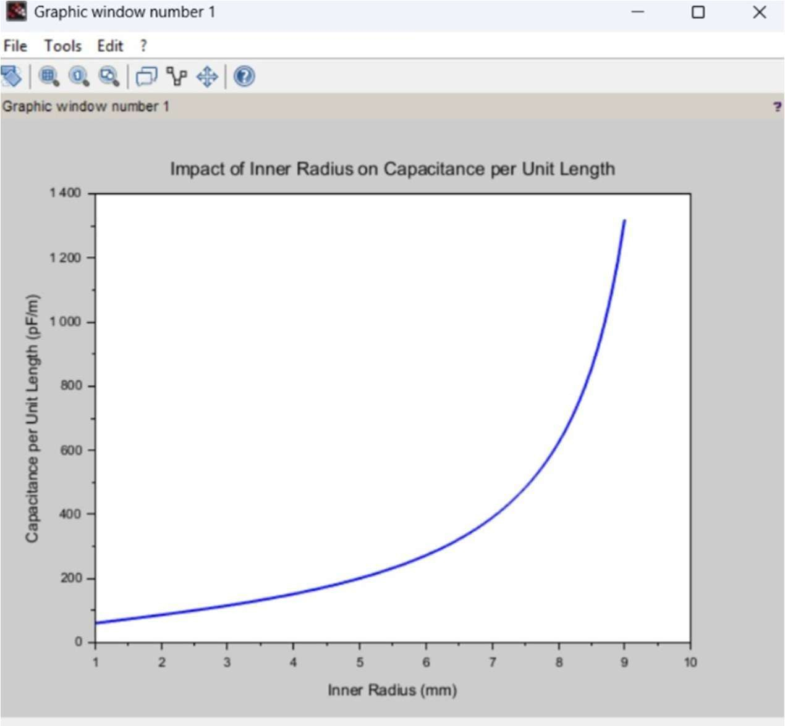

CASE STUDY 2: Variation with Outer Radius
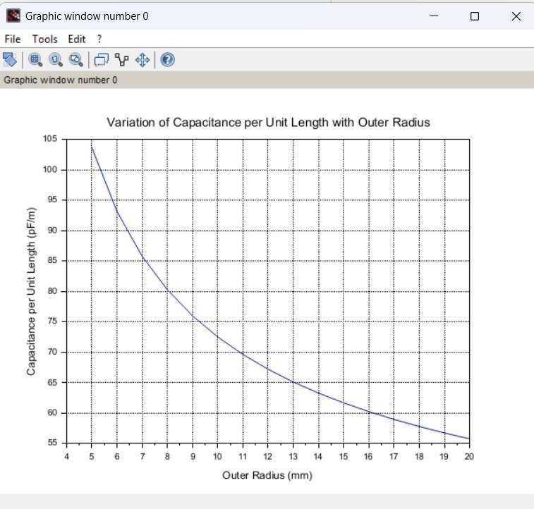

CASE STUDY 3: Variation with Relative Permittivity

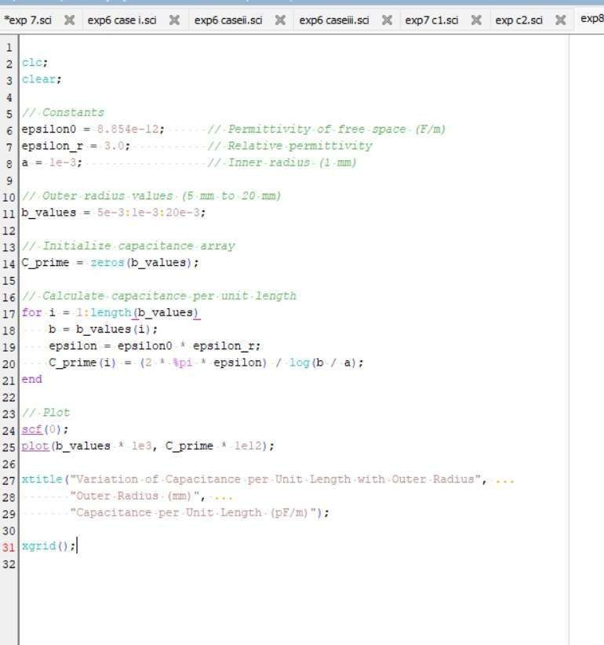

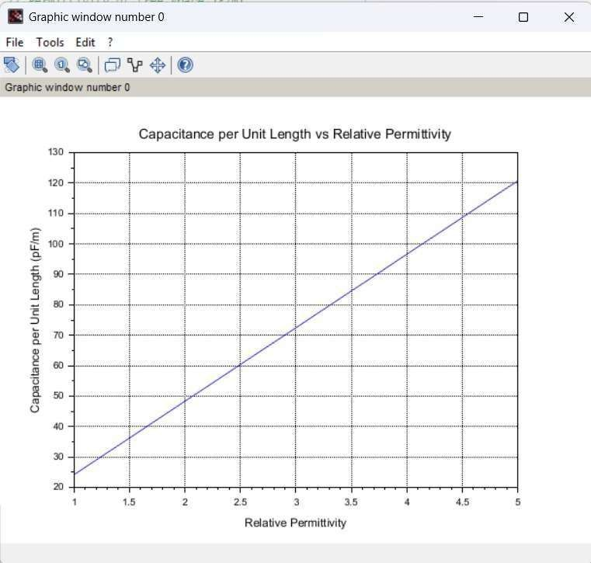

Result : Thus the program was verified for Capacitance of co-axial cable per unit length using SCILAB was successfully.

